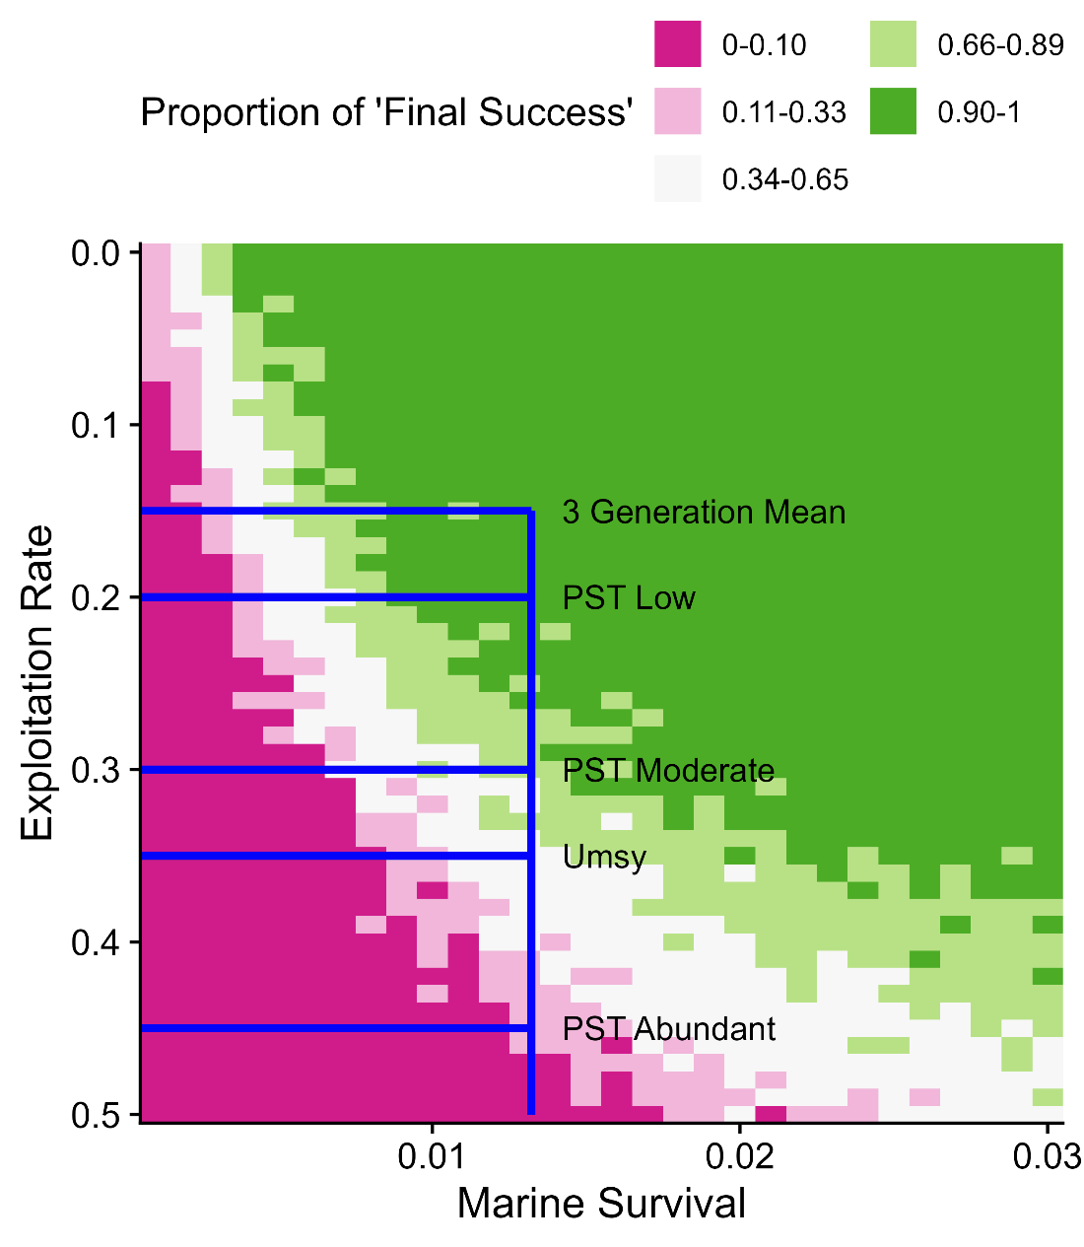

Figure xx. *Proportion of simulation results where the final 3-year geometric mean was ≥ 33,500 wild spawners (‘Final Success’). The blue lines intersect at the most recent 3-generation geometric mean smolt-to-adult survival (0.013; vertical blue line) and exploitation rates showing the current 3-generation average, Pacific Salmon Treaty (PST) rates based on IFC abundance, and Umsy as calculated from stock recruit models (see Table xx).*

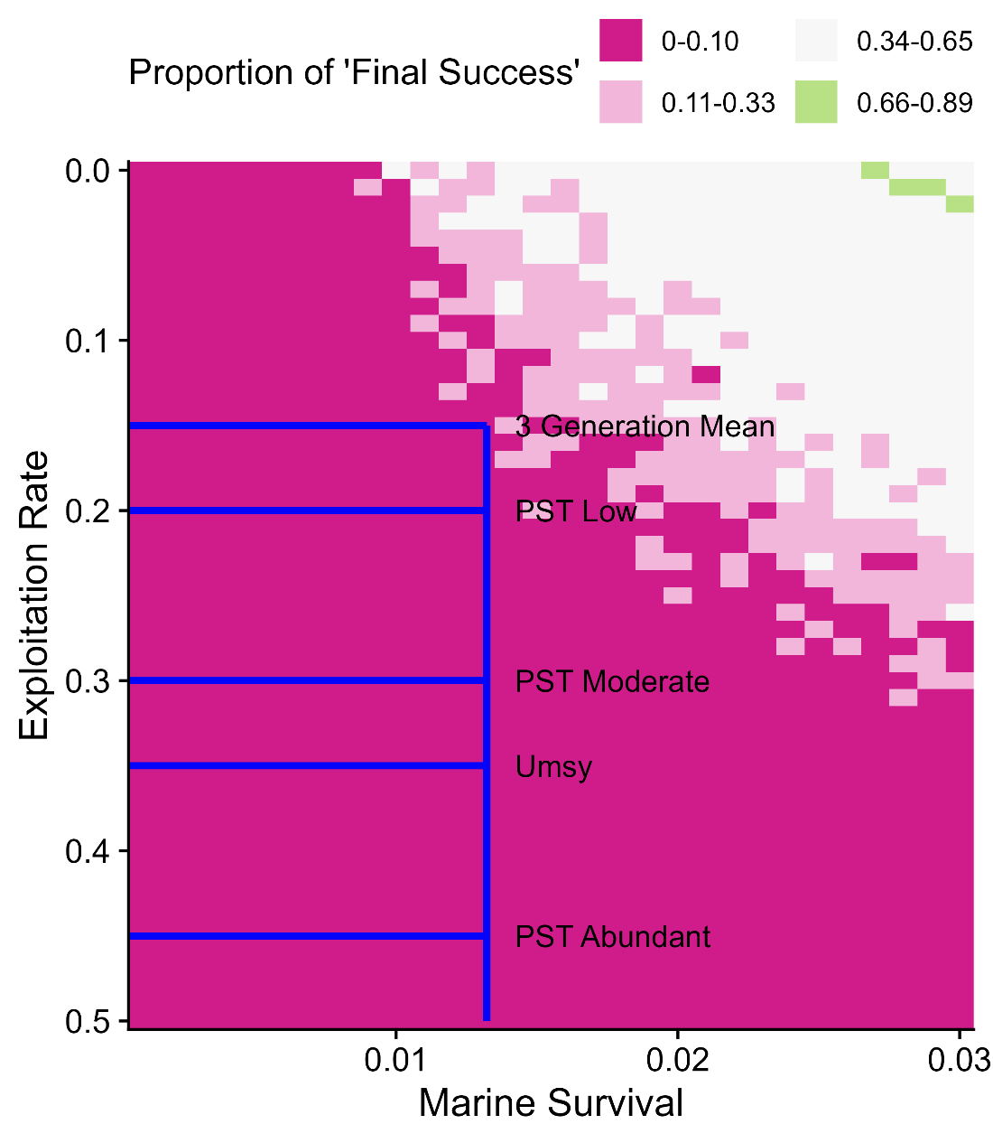

Figure xx. *Proportion of simulation results where the final 3-year geometric mean was ≥ 65,300 wild spawners (‘Final Success’). The blue lines intersect at the most recent 3-generation geometric mean smolt-to-adult survival (0.013; vertical blue line) and exploitation rates showing the current 3-generation average, Pacific Salmon Treaty (PST) rates based on IFC abundance, and Umsy as calculated from stock recruit models (see Table xx).*

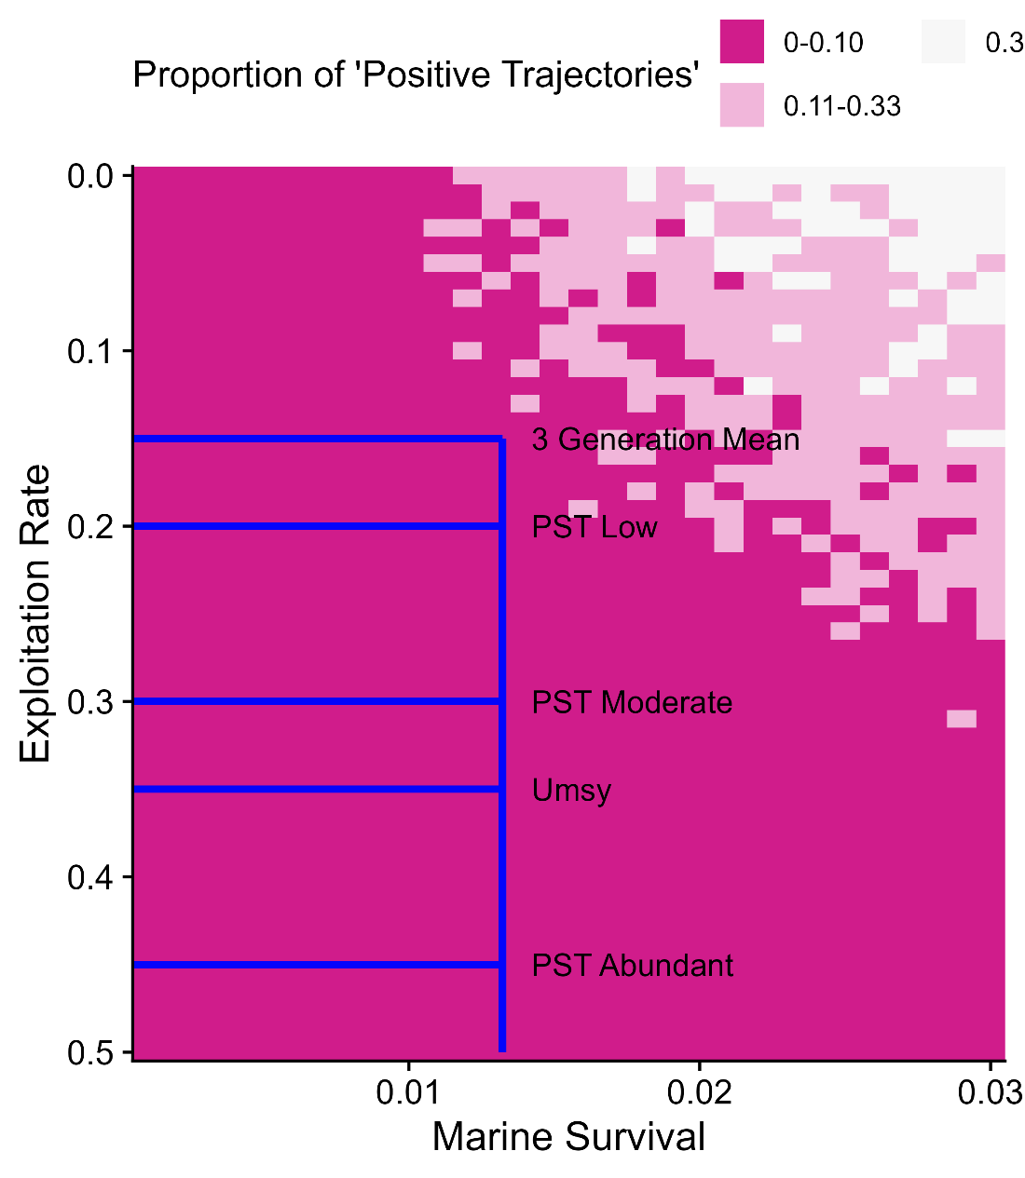

Figure xx. *Proportion of simulation results where the population trajectory was positive (‘Positive Trajectory’). The blue lines intersect at the most recent 3-generation geometric mean smolt-to-adult survival (0.013; vertical blue line) and exploitation rates showing the current 3-generation average, Pacific Salmon Treaty (PST) rates based on IFC abundance, and Umsy as calculated from stock recruit models (see Table xx).*

Build cheat sheet that links each terms of reference to work done in the document

